In this Assignment I have configured SNAT and DNAT

First i loaded up a ubuntu server with an Private IP of “10.10.1.100” and configured vmnet3 as it’s network adapter.

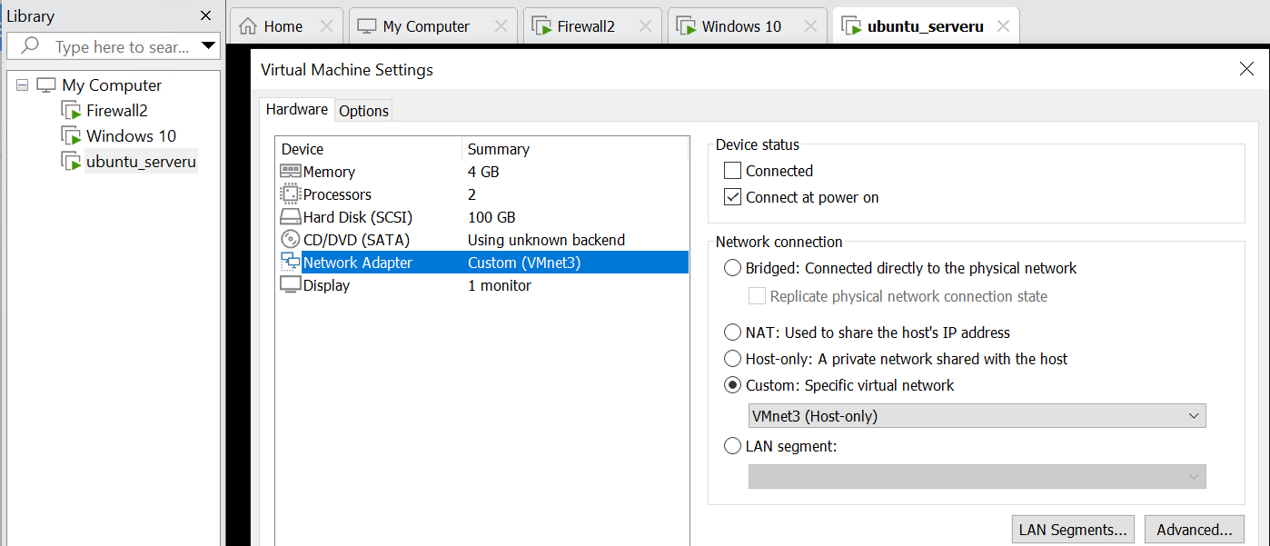

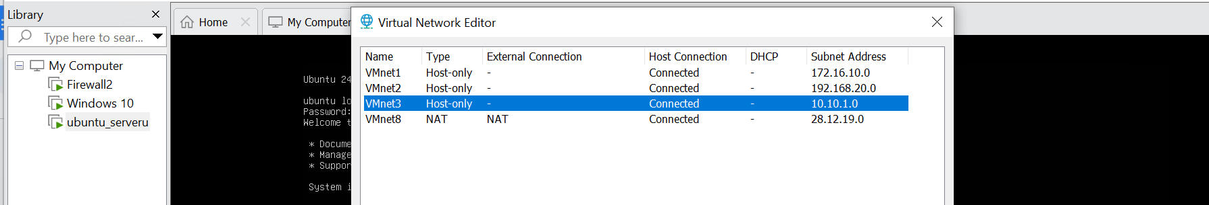

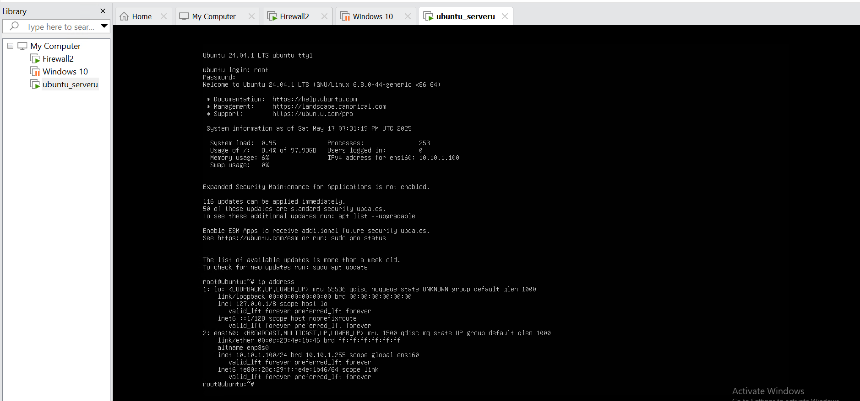

Here are the network objects and interfaces using which i have configured SNAT and DNAT

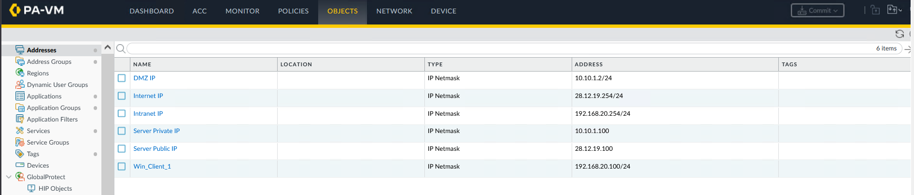

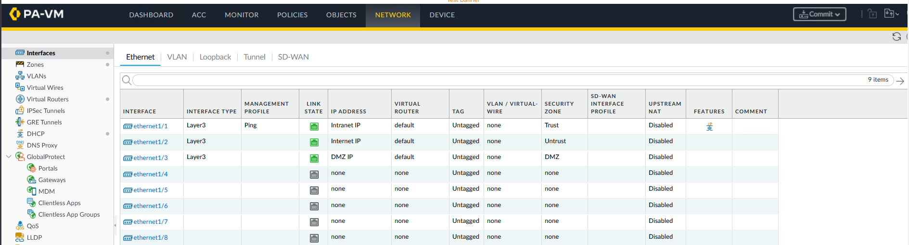

Then i have configured SNAT, DNAT and committed the configuration as shown below

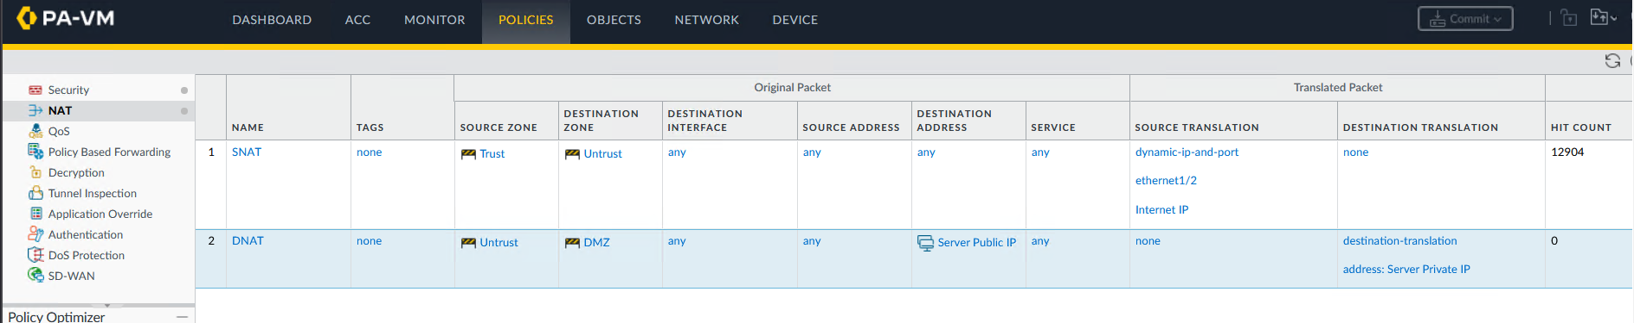

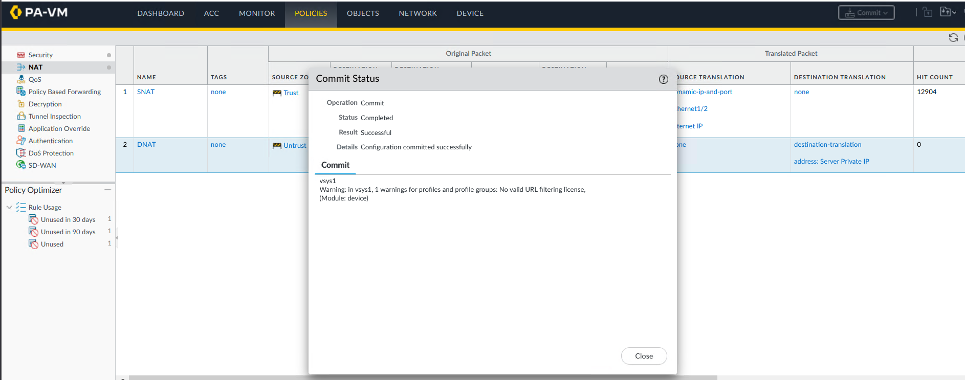

Here is a screenshot demonstrating a ping to the ubuntu server of IP ‘10.10.1.100’ in the DMZ zone from the client of IP ‘192.168.20.100’

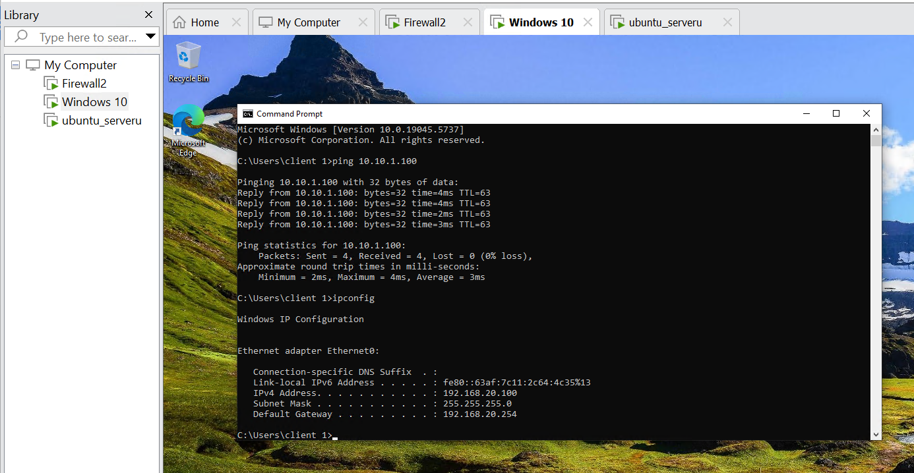

The client uses vmnet2 as it’s network adapter



